Collections Assignment

1.Given a TreeMap<Long.Contact> which has phone numbers for keys and contact objects for values.

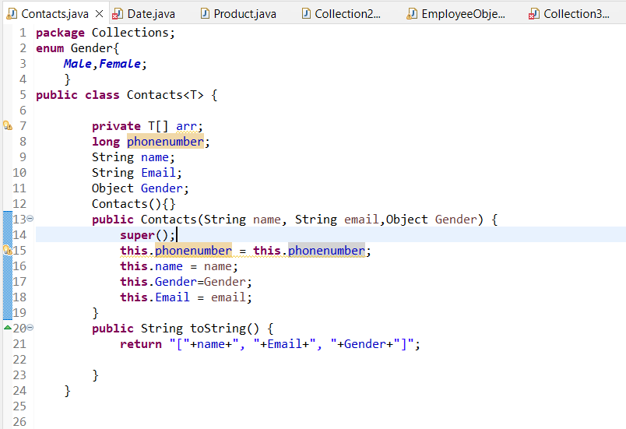

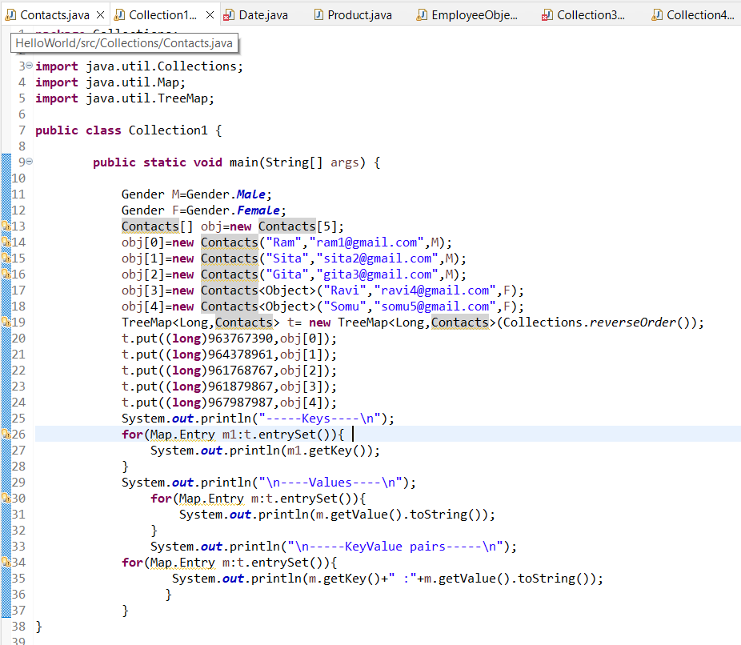

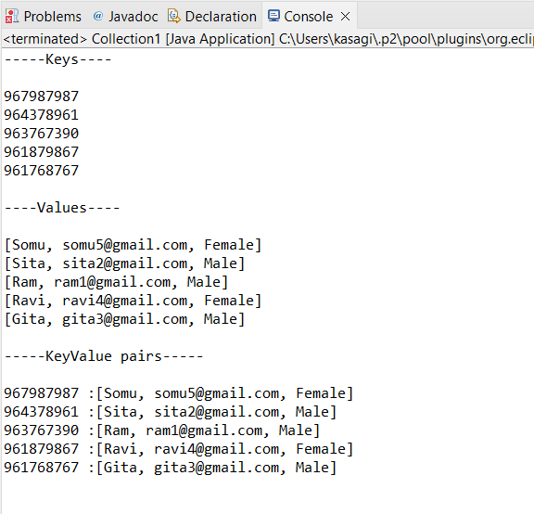

2. Write an application to store 10 unique product objects. In case there is an attempt to add a duplicate product. It should be silently rejected.

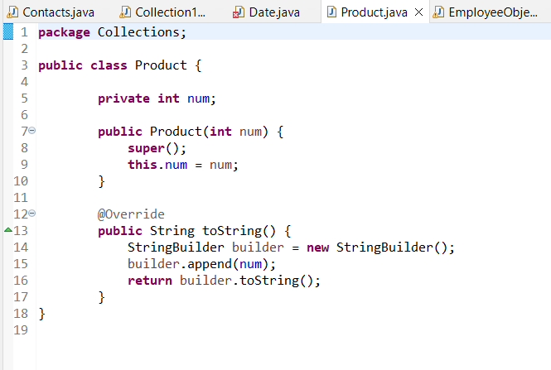

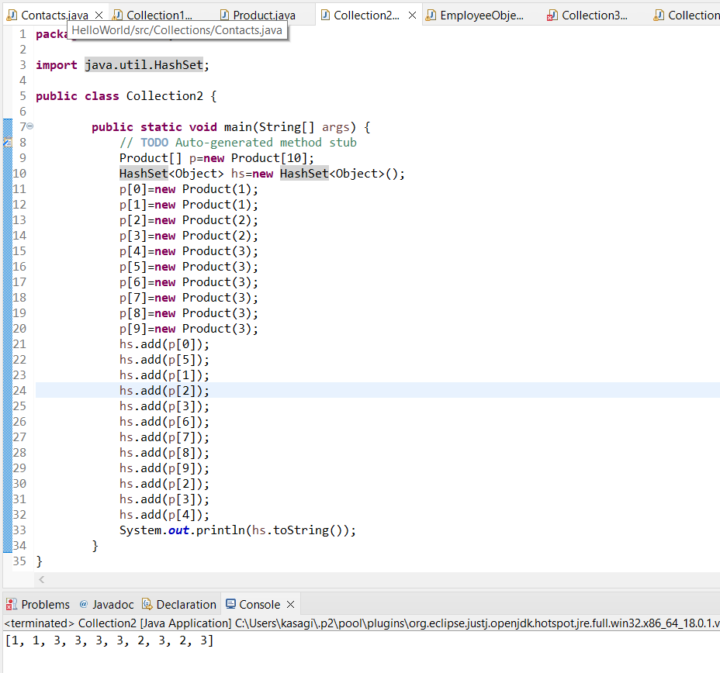

3. Store at least 10 Employee Objects in an TreeSet<Employee>. When the application runs the user should be asked to select one of the options upon which you will print the employee details in a sorted manner.

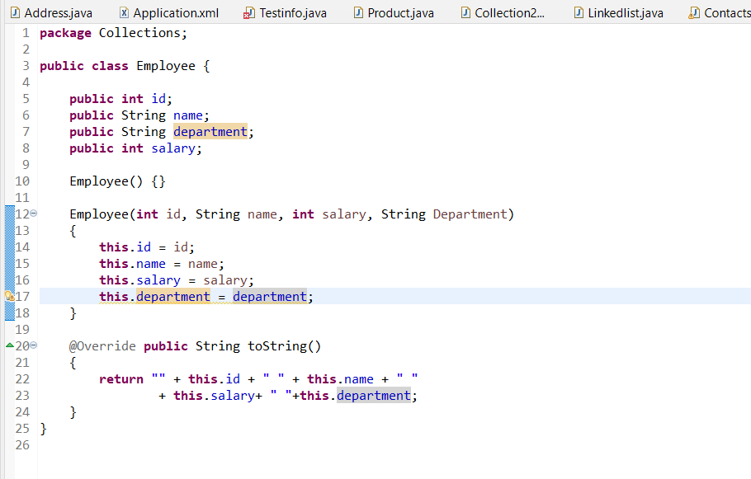

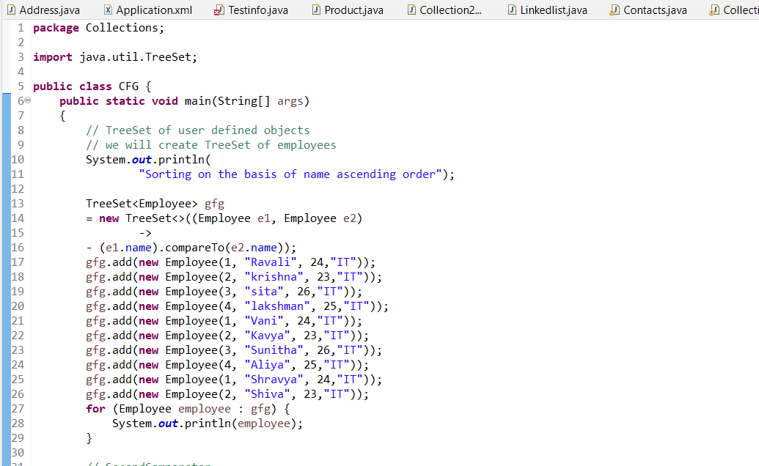

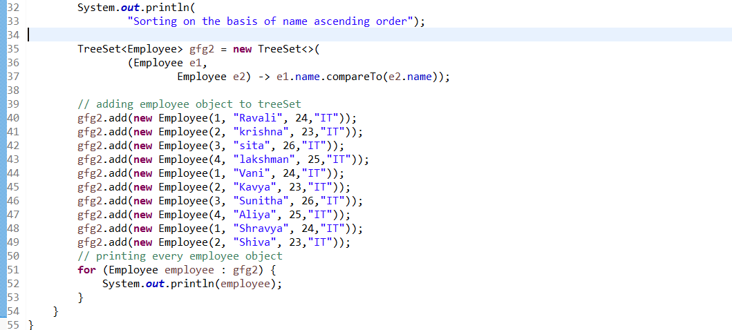

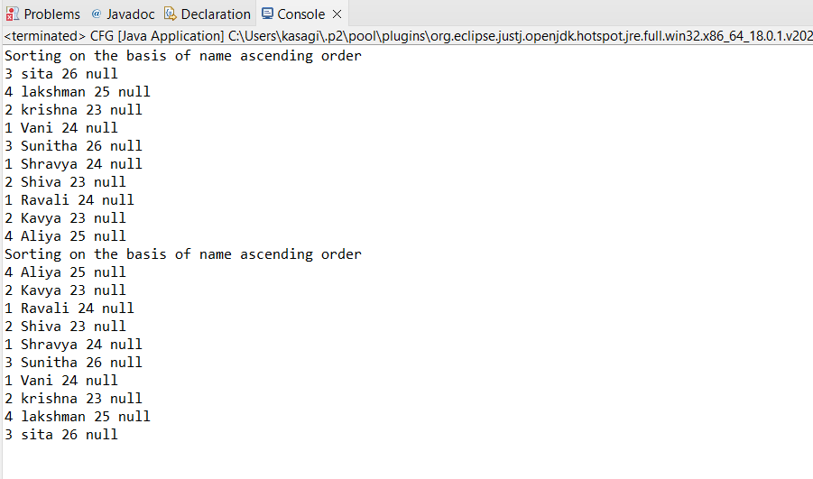

4. Given a LinkedList of Objects representing date of birth’s. Print the dates along with message.

